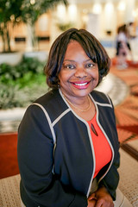
Melanie Ann Prince, MSS, MSN, RN, NE-BC, CCM, FAAN

Melanie A. Prince, is the President of Case Management Society of America (CMSA). She recently retired as Active Duty Military Colonel assigned to Headquarters Air Force where she was responsible for developing strategies to eliminate interpersonal violence in the military. Melanie is now the Chief Executive Officer, Care Associates Consulting. Melanie is a certified case manager and medical-surgical nurse with over 25 years of progressive leadership responsibilities and diverse clinical experiences in emergency medicine, inpatient care, disaster management, ambulatory health, population health and medical management. Her excitement and confidence in the principles of case management inaugurated the Air Force’s first independent Nurse Managed Clinic staffed exclusively by case managers, where patient outcomes were game-changers for medical management and population health. Recognized for fusing business acumen with clinical expertise to launch award-winning programs, Melanie is considered a subject matter expert in case, disease, and utilization management. Melanie is a graduate of Air University in Montgomery, Alabama, where she earned a Master’s Degree in Military Strategic Studies. She also has a Master’s Degree in Nursing with a concentration in Case Management from University of Arizona, and a Bachelor’s Degree in Nursing from University of Louisiana, Lafayette.

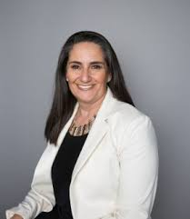

Aishling Dalton Kelly CADDCT,CFRDT,CMDTP,CDP,CECM

I am a Toast Master of five years. My previous speaking engagements follow: • CMSA National Conference Vegas – June 2019 • Private Duty Symposium – September 2019 • 8 Hour Monthly Alzheimer’s Dementia Disease Care training course and seminar – 2017 to Date My background and expertise combine to empower me to speak with authority on the subject matter. Using my Observant eye, and genuine grounded nature, I focus upon what is important to my audience. What are their pain points? What is most important to their professional development? I relate with my audience through their emotions and personal connection to the subject matter. I weave in humor and case studies to ensure my audience will leave energized and enlightened with new ideas and practices. Most of all - we have fun together!

Music & Memory

This presentation can be done both in person or virtually. New props will be used to facilitate the virtual platform. Participants will leave fully understanding the power of music as it is brought to the front of each attendees' minds by creatively using sound bites and visual effects. These special effects jog past memories of the audience. In short, their neurological pathways are reignited from familiar tunes from yesteryear that had specific personal meaning to the participant. This presentation will highlight how music can and does prevent challenging behaviors, it will also showcase that depression, & feelings of loneliness & isolation can be reduced by implementing a music & memory program. A very fun, hysterical, and engaging experience for every participant is guaranteed.

PENDING HEADSHOT

Dr Yakov Weil
Dr. Yakov Weil is the Director of Rehabilitation for Therapy Masters a division of Health and Home Management. In his role as Director, Dr.Weil supervises the physical, occupational, and speech therapies for seven facilities that provide long and short-term care including therapy following orthopedic surgery Dr. Weil has been instrumental in designing new state-of-the-art therapy rooms that incorporate high-tech,modern environments and allow the therapists to offer personalized caring therapy. Dr. Weil is a well known and frequently requested speaker in the Greater Chicagoland area. He lectures on many health related topics at numerous hospitals and professional associations. Dr. Weil has a unique ability to interject humor into his presentations making them as entertaining as they are educational. Dr. Weil received his B. A. in human Biology and his Doctorate in Chiropractic studies at the National University of Health Sciences. While in private practice, Dr. Weil helped establish a unique multi-disciplinary medical practice in Chicago. Dr. Weil lives in Las Vegas with his wife and family.
Digital Addiction
In our fast paced 24/7 world, we can't live without our smartphones and other digital devices. Are we addicted? In this presentation, the speaker explores the definition of digital addiction and how our brains react and change physically and emotionally to digital devices. How are our children affected by digital devices? Interventions are presented and strategies are discussed to use digital tools effectively and to maximize our productvity in this digital age.

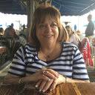
Lynn Muller JD, RN, BA-HCM, CCM
Dr. Muller is currently a practicing Attorney and the managing partner of Muller & Muller. Her practice includes defense of healthcare professionals before the state licensing boards, case management litigation, family law, wills, trusts and estates, as well as consulting representation of medical practitioners, and facilities on such issues as regulatory compliance and day-to-day operations. She received her nursing degree from Pace University and is a Registered Professional Nurse (RN). Dr. Muller went onto earn her Bachelor of Arts Degree in Health Care Management at St. Peter’s University of New Jersey and then her Juris Doctor from Quinnipiac University School of Law in Connecticut. Dr. Muller is a popular and sought-after keynote and session speaker at national and regional conferences. She is the Contributing Editor of Professional Case Management: The Official Journal of the Case Management Society of America (CMSA) and a recent member of the Board of Directors of CMSA of New York City. She is an adjunct Professor at Saint Peter’s University School of Nursing in the MSN and DNP Programs. Dr. Muller is the author of over 50 articles in nursing and case management journals and was featured in the Journal of Nurse Administrators. She is a contributor to the 2016 CMSA Standards of Practice and CMSA Career & Knowledge Pathways, the author of the Legal & Ethical Chapter of the 6th ed. of the Case and Population Health Chapter for Leadership and Nursing Case Management, published by Elsevier. Dr. Muller is the author of both legal chapters of the 3rd edition of Case Management: A Practical Guide for Education and Practice and 3rd edition of the CMSA Core Curriculum for Case Management. She is a former Commissioner for the Commission for Case Management Certification (CCMC), where she now serves on the Professional Development and Education Sub-Committee, as a Facilitator for the CMCC 360© 2-Day Immersion Program and is a contributor to the CCMC Case Management Body of Knowledge (CMBOK). She is a past President of the New Jersey Chapter of CMSA and the former Director of Social Services for the Borough of Bergenfield, N.J., a community-based case management program she developed and initiated. Dr. Muller has also served her community as public defender, municipal court judge, councilwoman and chaired the borough’s Barrier Free Committee. She is married to her law partner and grandmother of 4.

Malpractice: There’s more to it than you might think
When one thinks about malpractice, we typically think about an acute care setting and a serious act of malfeasance: wrong patient, wrong procedure, wrong body part . . . Case management practice is more complex and crosses into several areas of the law, Standards of Practice and Codes of Ethical Conduct. This session will provide the case manager with a more in depth look at how we do, what we do and how to protect ourselves. It will define malpractice in case management practice settings from face to face to telephonic and remote access.

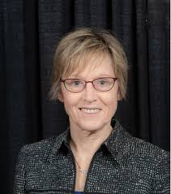
Mary Beth Billie, DNP, RN-BC, CCM

Mary Beth Billie is a registered nurse with over 30 years of experience developing and managing utilization, case, disease and population health programs in provider and payer organizations. Mary Beth is a certified in Case Management from both the CCMC and the AACN. She is an adjunct faculty member in the nursing program at Benedictine University in Lisle, Illinois. She received her Doctorate of Nursing Practice (DNP) from Loyola University Niehoff School of Nursing. Her Capstone project was implementing a Serious Illness (SI) educational program and Serious Illness Protocol for nurse and social worker case managers in an Accountable Care Organization. Her Serious Illness project was published in the Professional Case Management Journal (Billie and Letizia, 2020). She has taught the Serious Illness Program to over 150 case managers. She presented her Serious Illness Program at the 2020 National CMSA Conference. She has presented several posters on this topic, including the 2019 National Center to Advance Palliative Care Conference. She has also done Serious Illness presentations to Physician Organizations and Nursing Students. Her most recent position was the Regional Executive Director of Population Heath at Loyola University Health System in Maywood Illinois. In that role she developed and implemented care coordination and quality management programs for Loyola’s Physician Partners Accountable Care Organization. Mary Beth previously held leadership positions at Blue Cross of Illinois and United Health Care where she was responsible for National Care Management and Population Health programs. Mary Beth has developed and implemented care manager training programs using the Chronic Illness Trajectory framework to provide care managers with a structured approach to identifying and mitigating clinical, financial and psycho-social risks for high risk patients.

Serious Illness Communication

Abstract Purpose/Objectives: The purpose of this project was to develop, implement and evaluate an educational program and Serious Illness (SI) protocol for a case management team of nurses and social workers to achieve the following: (1) utilize a serious illness protocol to identify patients with serious illness; (2) utilize a Serious Illness Structured Communication Guide to elicit these patients’ goals and preferences for serious illness care; and (3) document in the electronic medical record the patients’ elicited values and goals using a structured serious illness documentation template.

Implications for Case Management Practice: • Case managers may not have had formal or informal education about engaging in conversations with patients living with a serious illness(s), regarding their goals of care and advanced care planning. Such education is essential, particularly if serious illness conversations are within the case managers’ role and responsibility. • Establishing a protocol for case managers to follow is essential, including identifying patients appropriate for a serious illness conversation; conducting a serious illness conversation; and documenting information from the serious illness conversation in the electronic medical record. • Conducting serious illness conversations with appropriately identified patients is expected to result in the establishment of a plan of care consistent with patient preferences.

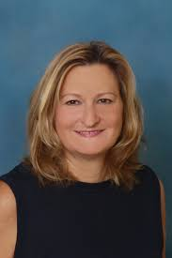
Deanna Cooper Gillingham RN, CCM

Deanna Cooper Gillingham is an RN, Certified Case Manager, Author, and Entrepreneur. She has extensive clinical and case management experience including complex case management, transplant case management, Med Surg, Dialysis, Oncology, Hospice, SICU, LDRP, L&D, and Ambulatory Care. She has also worked as a travel nurse, agency nurse, and patient service representative. Deanna is the author of CCM Certification Made Easy: Your Guide to Passing the Certified Case Manager Exam and Foundations of Case Management. She is the developer of several courses for nurses and case managers. Deanna is passionate about developing the case management workforce. As co-founder and CEO of the Case Management Institute, she is dedicated to decreasing barriers to entry into this profession and developing case managers into leaders. She is also the leader and co-founder of the Case Managers Community, a Facebook group of over 15,000 committed case managers. She is currently living her dream life in Puerto Aventuras, Mexico. From there she is writing her next book or course from her patio overlooking the beautiful Caribbean Sea. Unless that is, she is traveling the world with her friends and family.

All Aboard the Mentor-ship

Most case managers learn the profession through on the job training. While this teaches how to do the tasks of case management at that organization, the very heart of what case management is can be lost. Lack of consistent training and education in the profession leads to inconsistencies and subpar outcomes. One solution is mentorship. Mentorship allows you to share your passion and expertise to guide others on their career path while leaving a legacy. Imagine the satisfaction in knowing that you were instrumental in ensuring that quality case management is being provided by the next generation of case managers. Whether you have spent your entire career in case management or are just a few steps ahead of those whom you mentor, you can make a difference. This session will look at various ways you can impact the profession of case management through mentorship. You will walk away with tools and tactics to make mentoring easy, fun, impactful, and rewarding.

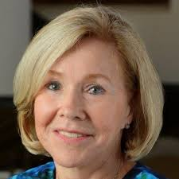

Nancy Skinner RN-BC, CCM, ACM-RN, CMCN

Nancy has for the past 30 years served as a case manager, Director of Case Management and an international case management educator. In her current role as principal consultant for Riverside HealthCare Consulting, she advances programs that promote excellence in care coordination and other transitional care strategies. She has presented over 400 on-site programs and webinars within the past ten years that offer a primary focus on supporting and enhancing the professional practice of healthcare case management and care coordination. In 2002, she was named the Case Management Society of America (CMSA) National Case Manager of the Year and in 2008, she received CMSA’s Lifetime Achievement Award. She is also recognized as being the only National President of CMSA to be elected to two terms of office; accepting that role in 1997 - 1998 and again from 2012 through 2014. She currently serves as a Board Member for the Hospital Quality Foundation and a merit reviewer for the Patient Centered Outcome Research Institute. Additionally, she assisted in the development of Post-Discharge Accreditation Standards for Cardiovascular Disease in partnership with the Society of Cardiovascular Patient Care. Nancy was a member of both the Stakeholders Advisory Group for Project ACHIEVE and the Steering Committee for the Lambert Center for the Study of Medicinal Cannabis and Hemp. She is a Member of the Public Policy Committee for the American Case Management Society and served as a Member-At-Large for the Kentucky/Tennessee Chapter of the American Case Management Society. Nancy is a member of American Cannabis Nurses Association and was invited to serve as a member of ACNA's National Conference Committee. She also recently retired as primary faculty for the University of Southern Indiana Case Management Certificate Course; a role she maintained for over 13 years.

Case Management – Putting the Pieces Together

As the practice of case management expands into all healthcare delivery and payer systems, we must endeavor to not only embrace the opportunity to more comprehensively impact the quality of provided care but also embrace the associated responsibilities and accountabilities associated with a professional practice of case management. Additionally, we must realize the value of working collaboratively across practice settings to advance the healthcare outcomes our patients are striving to achieve. While CMS continually seeks the interoperability of systems, I believe we truly need greater connectivity and communication among case managers. We have the ability to move the practice of case management from where it is today to where that professional practice is required to be tomorrow. This presentation will address the value of transdisciplinary teams working collaboratively to advance quality and appropriateness of care for the patients we serve.

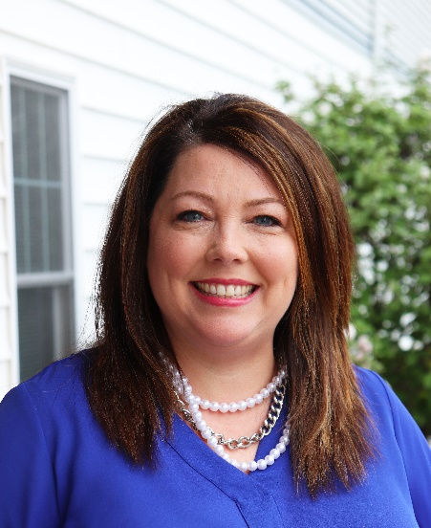

Sara Sefried B.S., ICDVP

Sara spearheaded the creation of the Center for Prevention of Abuse’s Human Trafficking Services in 2017 and oversees all anti-trafficking efforts for foreign born and domestic survivors in labor and sex trafficking. She is the Director of Human Trafficking Services and facilitates trainings for law enforcement, medical providers, community organizations, first responders, and participates in legislative discussion surrounding anti-trafficking efforts. Sara joined CFPA in 2006. Before developing the Center’s Human Trafficking Program, Sara served as the Director of Domestic Violence Family Centered Services. She supervised two domestic violence shelters, an 11 unit transitional housing program, and domestic violence counseling services for adults and children. She is an active speaker on human trafficking, both locally and on a national level. She is dedicated to educating our community by raising awareness and providing specialized services for survivors.

Human Trafficking- What You Need to Know

Human trafficking not only crosses national and international borders, but also surfaces at the street level within our local communities. Illinois currently ranks 10th in reports to the National Human Trafficking Hotline. Law enforcement, medical providers, and social service agencies often are likely to come into contact with this covert crime and play a critical role in identifying and responding to human trafficking victims. However most agencies are not familiar with the signs of human trafficking, relevant laws or appropriate response. Learning Objectives: Define Human Trafficking Identify populations vulnerable to human trafficking Learn the common red flags associated with sex and labor trafficking Understand the mindset of a victim Become familiar with the laws protecting victims of human trafficking Understand the importance of taking a trauma informed approach Become familiar with the resources and benefits available to victims Learn about human trafficking trends in Illinois Training Format: Receive engaging and relevant instructor led classroom training. The instructor will utilize PowerPoint, video clips and encourage participant discussion to successfully meet the learning objectives. Participants will receive supplemental materials to reinforce the training material.

